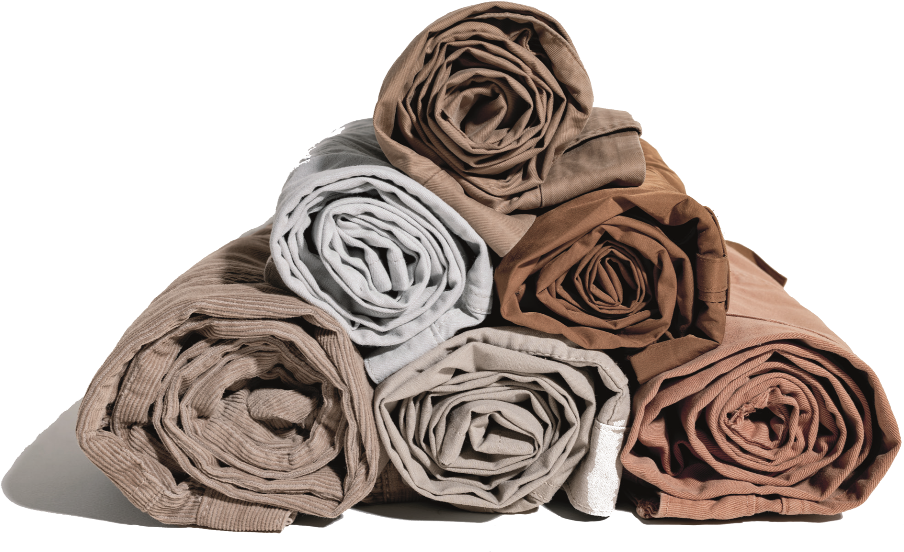

**COMPANY**

**PROFILE**

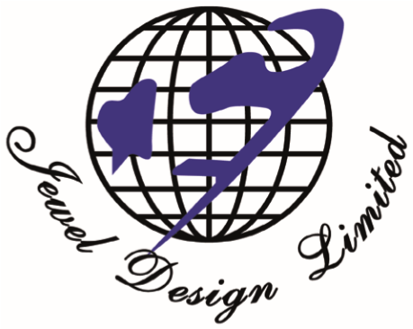

**Crafting Comfort**

**Elevating Fashion**

# TABLE

# OF CONTENT

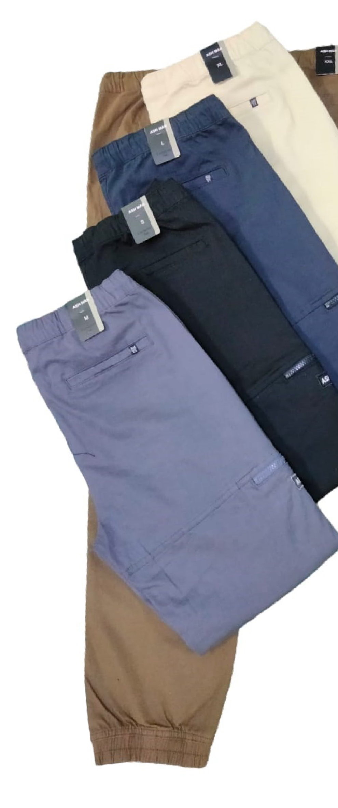

**COMPANY VALUES**

**MESSAGE**

**PRODUCT**

**MANUFACTURED**

**PRODUCTION CAPACITY**

**LIST OF MACHINES**

**CLIENTS**

**MEMBERSHIP &**

**CERTIFICATION**

**COMPANY HISTORY**

**ORGANOGRAM**

|  |
| --- |
| **Vision**  We aspire to become a trusted partner for fashion brands and retailers worldwide, empowering them to deliver stylish and sustainable apparel to their customers.  **Mission**  Ascend to the pinnacle of Bangladesh's garment export industry, establishing a benchmark for excellence and pioneering practices.. We are committed to fostering a diverse and ethical work environment that empowers 2,000 individuals in Bangladesh to thrive professionally and personally. |

**COMPANY VALUES**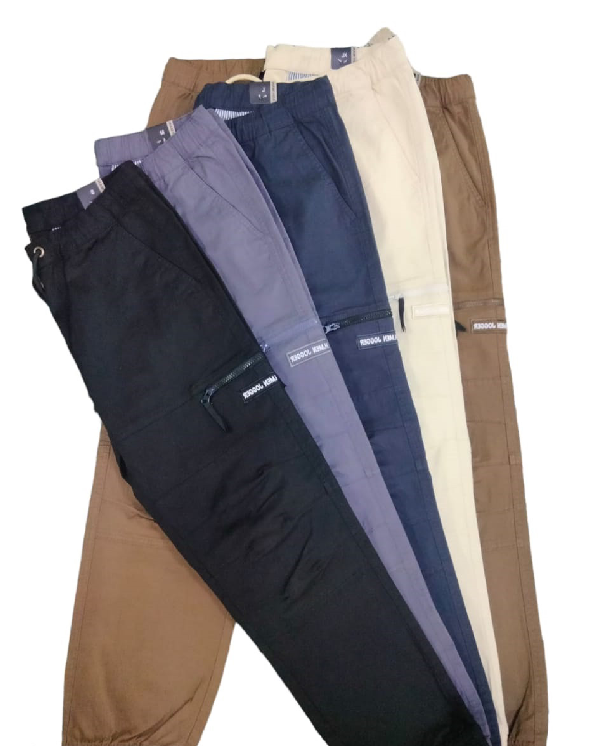

# MESSAGE

**Hazi MD Osman Sikder, Chairman**

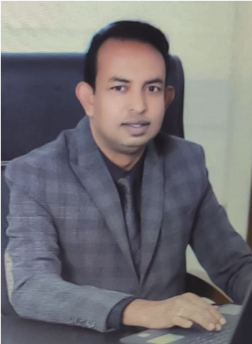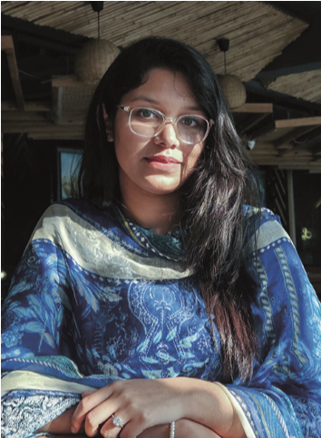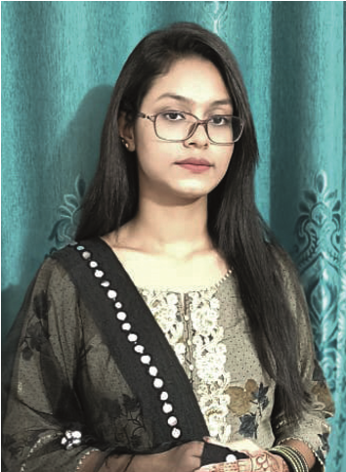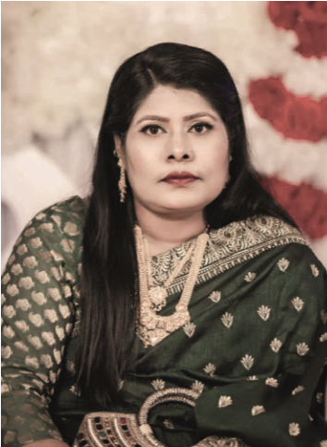

We are not only proud of our rich heritage but also deeply committed to ethi- cal and sustainable practices. We believe in the power of fashion to inspire, empower, and connect individuals across borders, while minimizing our envi- ronmental impact. We are committed to fostering a diverse and inclusive work environment that attracts and retains the brightest minds in the industry. We embraced circular fashion and believe that fashion can be a force for good, and we are committed to it.

**MD Jewel Hossain, Managing DirectorChairman**

Guided by a steadfast dedication to excellence, sustainability, and ethical prac"At Jewel Design Limited, we are not only proud of our rich heritage but also deeply committed to ethical and tice, we are committed to creating a diverse and empowering work environment sustainable practices. We believe in the power of fashion to inspire, empower, and connect individuals across that nurtures the talents of our people, enabling us to deliver exceptional prodborders, while also recognizing our responsibility to minimize our environmental impact. We are committed to ucts and services to our customers worldwide. As we navigate the ever-changing fostering a diverse and inclusive work environment that attracts and retains the brightest minds in the industry, fashion industry, we remain committed to our mission to become a global leader enabling us to achieve our ambitious goals. We are embracing circular fashion principles, extending the lifecycle of in garment manufacturing, leaving a positive impact on the communities we our garments, and reducing our reliance on virgin resources. We believe that fashion can be a force for good, and we

serve. are committed to playing a leading role in shaping a more sustainable and ethical industry."

**Tamanna Akter, Director**

Jewel Design Limited is committed to sound financial management and sustainable growth. We are focused on maximizing shareholder value while maintaining a robust financial position that supports our long-term goals. We believe in the power of strategic partnerships and investments to fuel our expansion plans and strengthen our competitive edge. Our financial strategy is aligned with our commitment to ethical and sustainable practices, ensuring that our growth positively impacts the communities we serve.

**Tanzila Akter, Director**

Our journey, spanning over a decade, is a testament to the power of determination, the fuel of passion, and the unwavering belief in the transformative potential of fashion. From our humble beginnings as a buying house to our current position as a leading garment manufacturer, we have consistently pushed the boundaries.Our success is not merely a measure of our market share or financial growth; it is the culmination of countless individual efforts, the collective spirit of our team.

# COMPANY HISTORY

**2026: Establishing an End-to-End Manufacturing Platform**

Demonstrating its commitment to efficiency and on time delivery, Jewel Design Limited is currently developing a 2 lac sqf 6-floor multi-express building, which will serve as the office of the group of companies and house an end-to-end manufacturing platform for RMG. This ambitious project is expected to be completed by 2026 and will further enhance 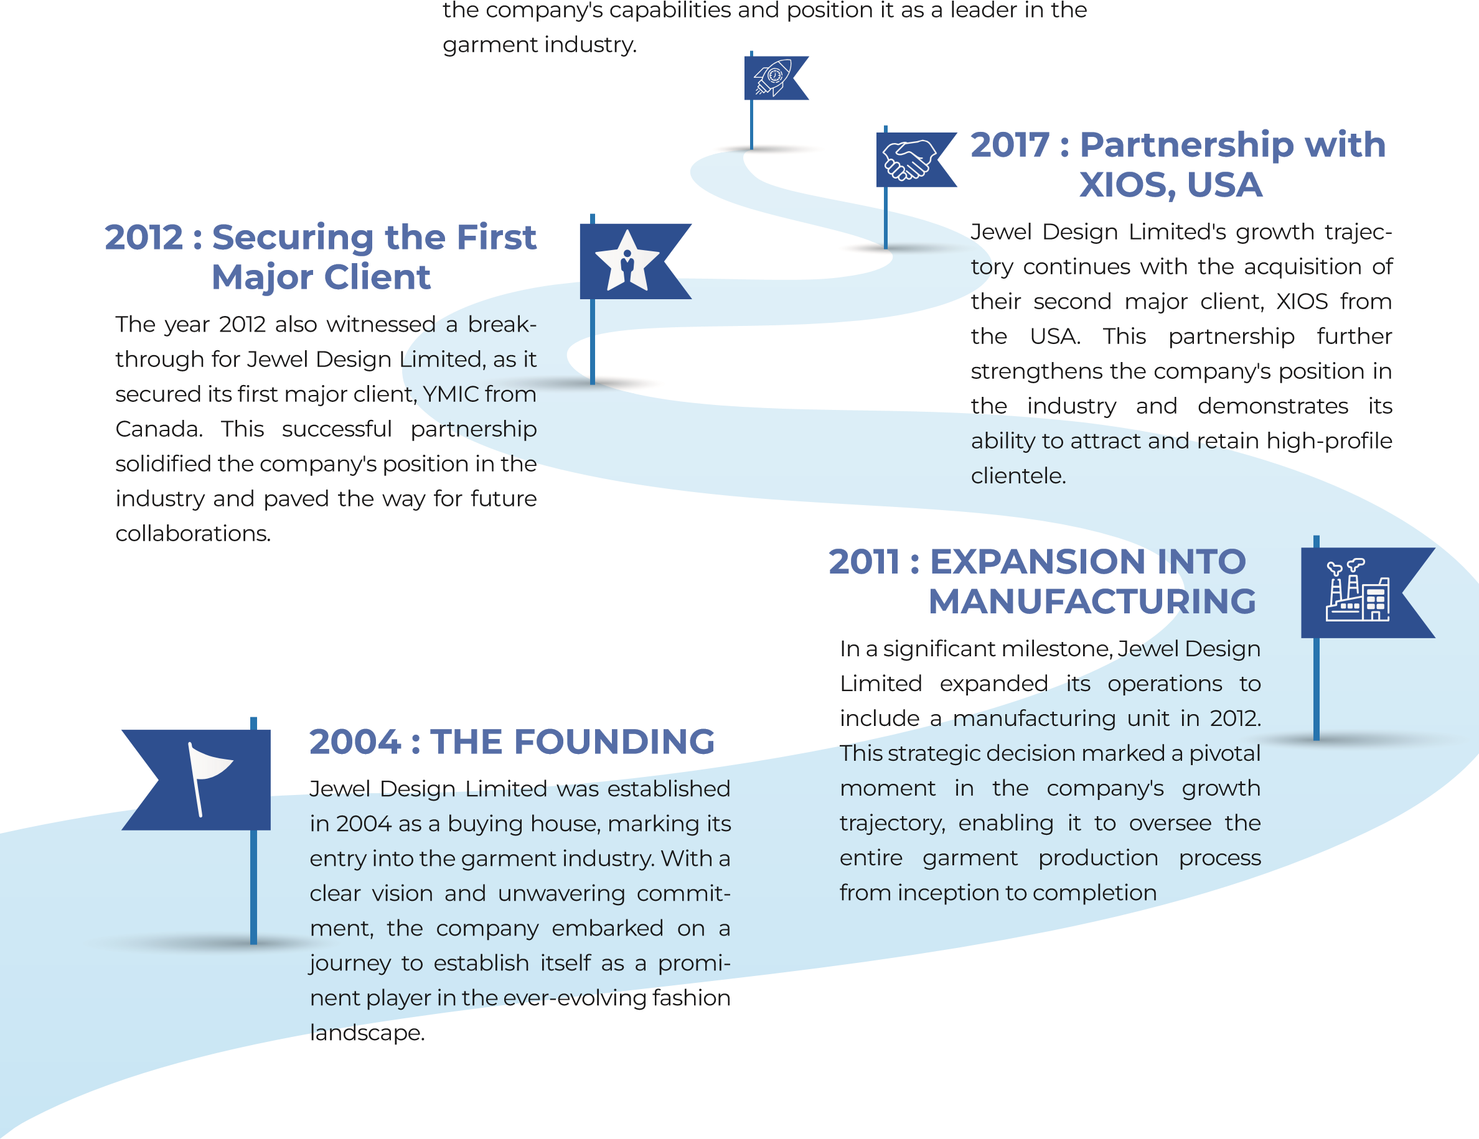

# ORGANOGRAM

**Marketing**

**Accounts**

**Head**

**Merchandiser**

**Customer**

**Acquisition**

**Commercial**

**Offers**

**Accountants**

**Managing**

**Director**

**Chairman**

**Central QC**

**Manager**

**GPQ**

**Auditors**

**Production**

**Manager**

**Sewing**

**Manager**

**Finishing**

**Manager**

**Fabric /**

**Cutting**

**Manager**

**Board of**

**Director**

**Production**

**Manager**

**Sewing**

**Manager**

**Finishing**

**Manager**

**Fabric /**

**Cutting**

**Manager**

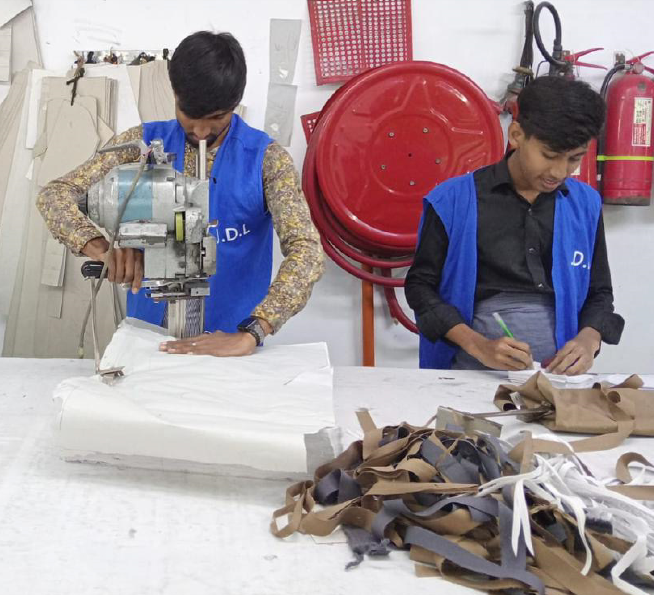

**PRODUCT**

**MANUFACTURED**

**Jewel Design Limited manufactures a wide range**

**of denim and woven garments for men and**

**women. The company's products include:**

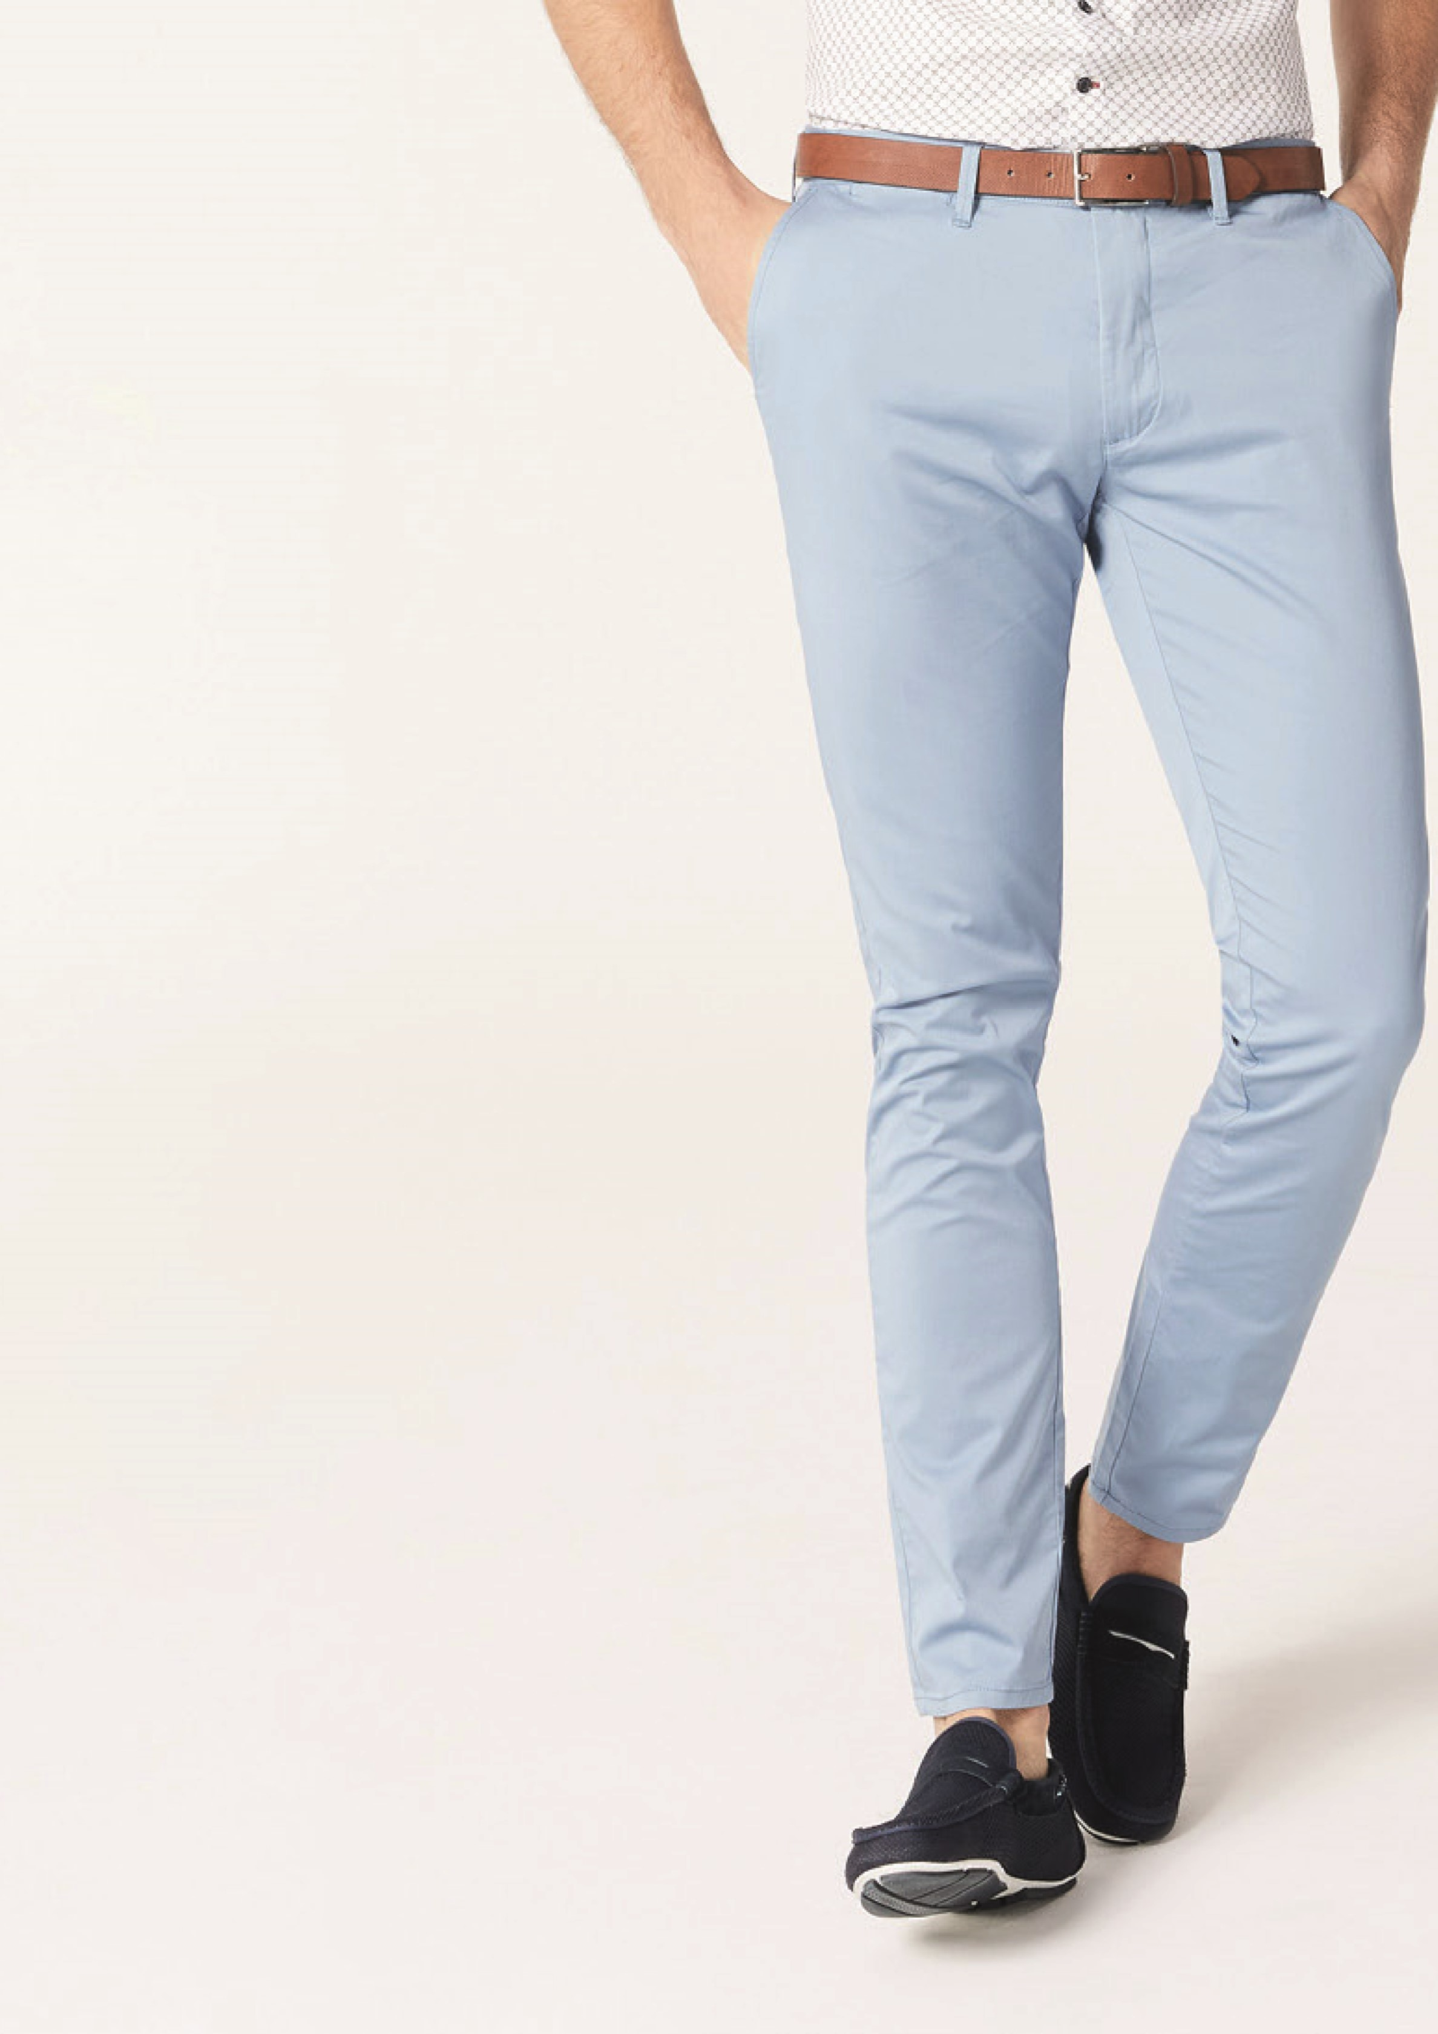

**MEN’S CHINO**

Men's

chinos

are

a

type

of

smart-casual

trouser

made

from

cotton

twill

with

a

small

amount

of

elastane for extra stretch. Unlike suit

pants, they do not have a pleat down

the front and usually have jetted back

pockets. Chinos are versatile pants that

can

be

worn

in

a

variety

of

set

tings.While

chinos

can

be

dressed

up,

it's

essential

to

note

that

they

are

not

suitable

for

strictly

formal

events

like

black-tie occasions, where a suit or tuxedo

is expected.

Chinos

are

typically

constructed

of

light

weight twill or stretch cotton for breathabili

ty

and

freedom

of

movement.

They

are

more

practical

than

suit

pants,

which

are

typically made of fine new wool and have a

lining

up

to

the

knee

for

comfort.

Market

segments

who

value

comfort

would

be

biased to wear chinos even over jeans.

If

your

brand

is

targeting

casual

and

semi-casual

dressers,

then

manufacturing

with

us

will

ensure

that

your

customers

receive outstanding quality of workmanship.

We

use

only

the

finest

materials

and

con

struction techniques to create clothing that

is both stylish and durable. Our garments are

designed to last, and our customers can be

confident

that

they

are

getting

a

quality

product that will make them look their best.

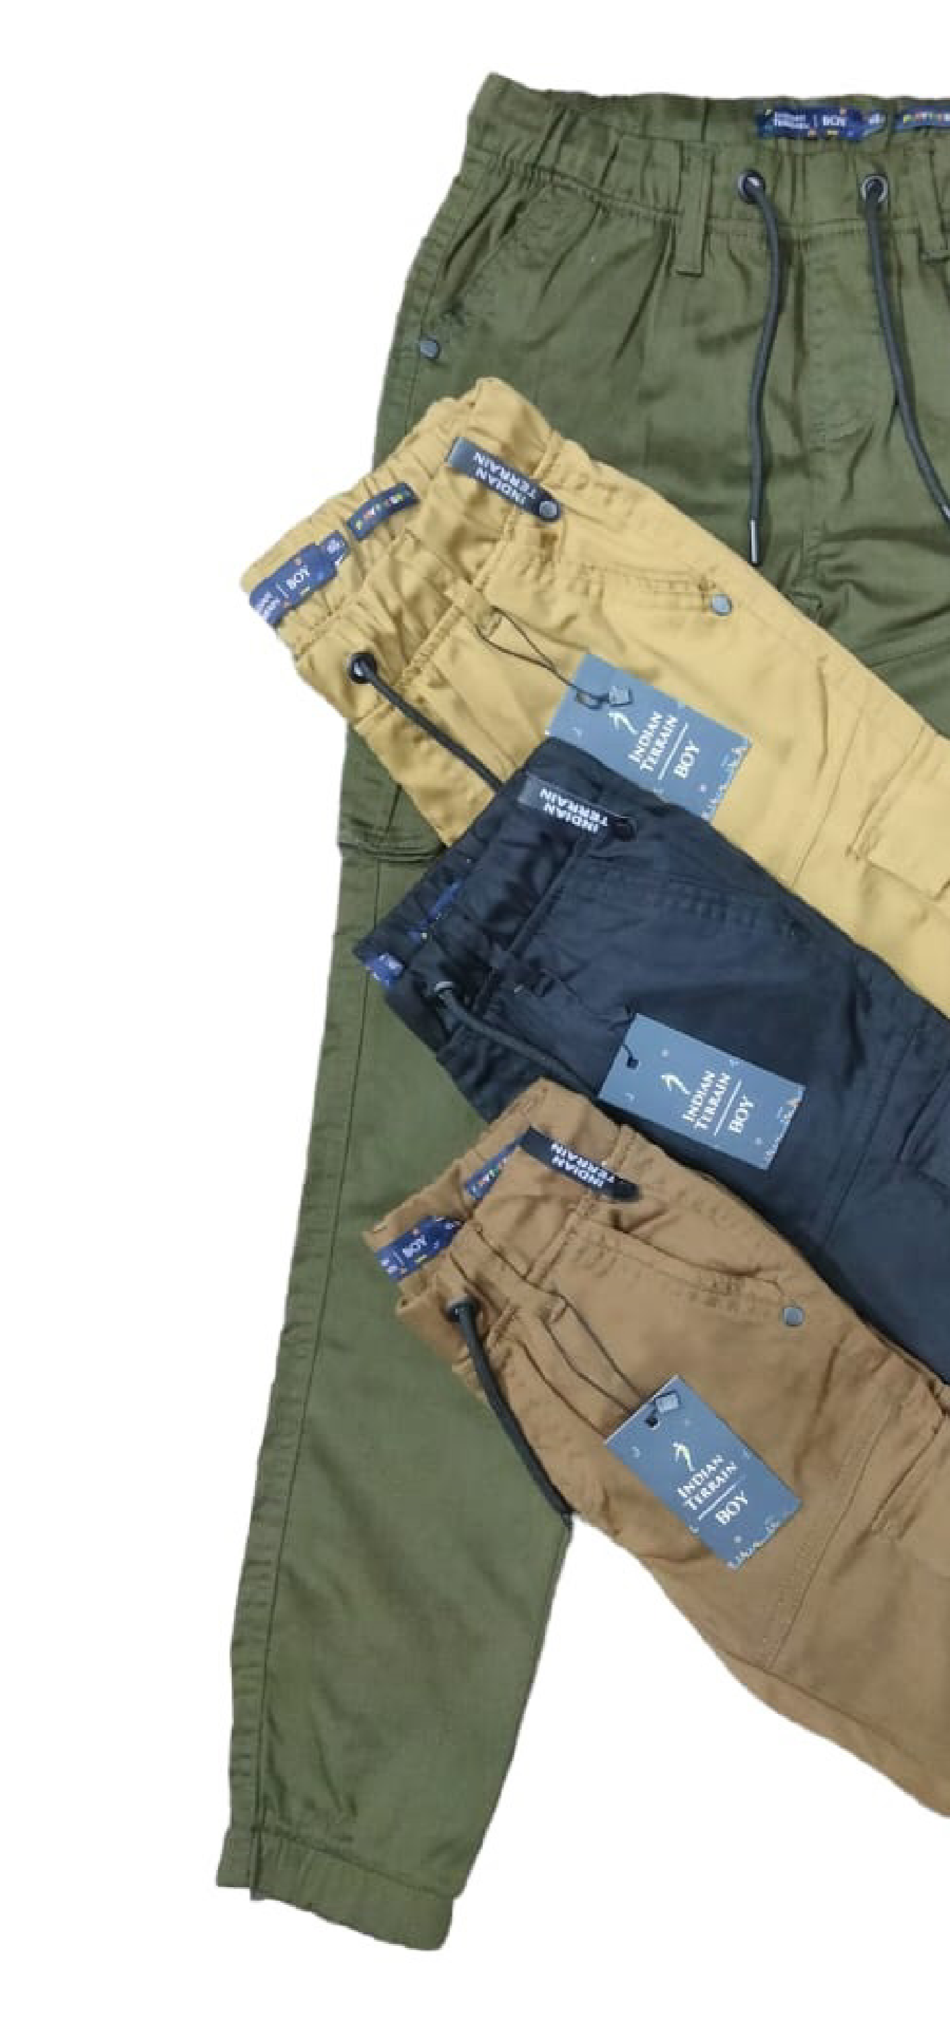**CARGO PANTS**

Cargo pants are a type of casual pants that are typically made of cotton or cotton-polyester blend. They are characterized by their large cargo pockets, which are often used to carry tools or other items. Cargo pants are often worn for outdoor activities or for work in the military or construction.

Cargo pants are a versatile piece of clothing that can be dressed up or down. They can be worn with a t-shirt and sneakers for a casual look, or with a button-down shirt and blazer for a more formal look. Cargo pants are also a popular choice for travel, as they are comfortable and can be easily packed.

In the late '90s, cargo trousers were all the rage. Throughout this time, they crossed over from being considered military or labor to being considered fashionable. Many people, especially those interested in urban and streetwear fashion, appreciated its loose cut and numerous pockets. Cargo pants have been making a major comeback on the streets from fall 2023 and onward. If your brand is targeting people looking for fashionable and comfortable streetwear, we are here to help.

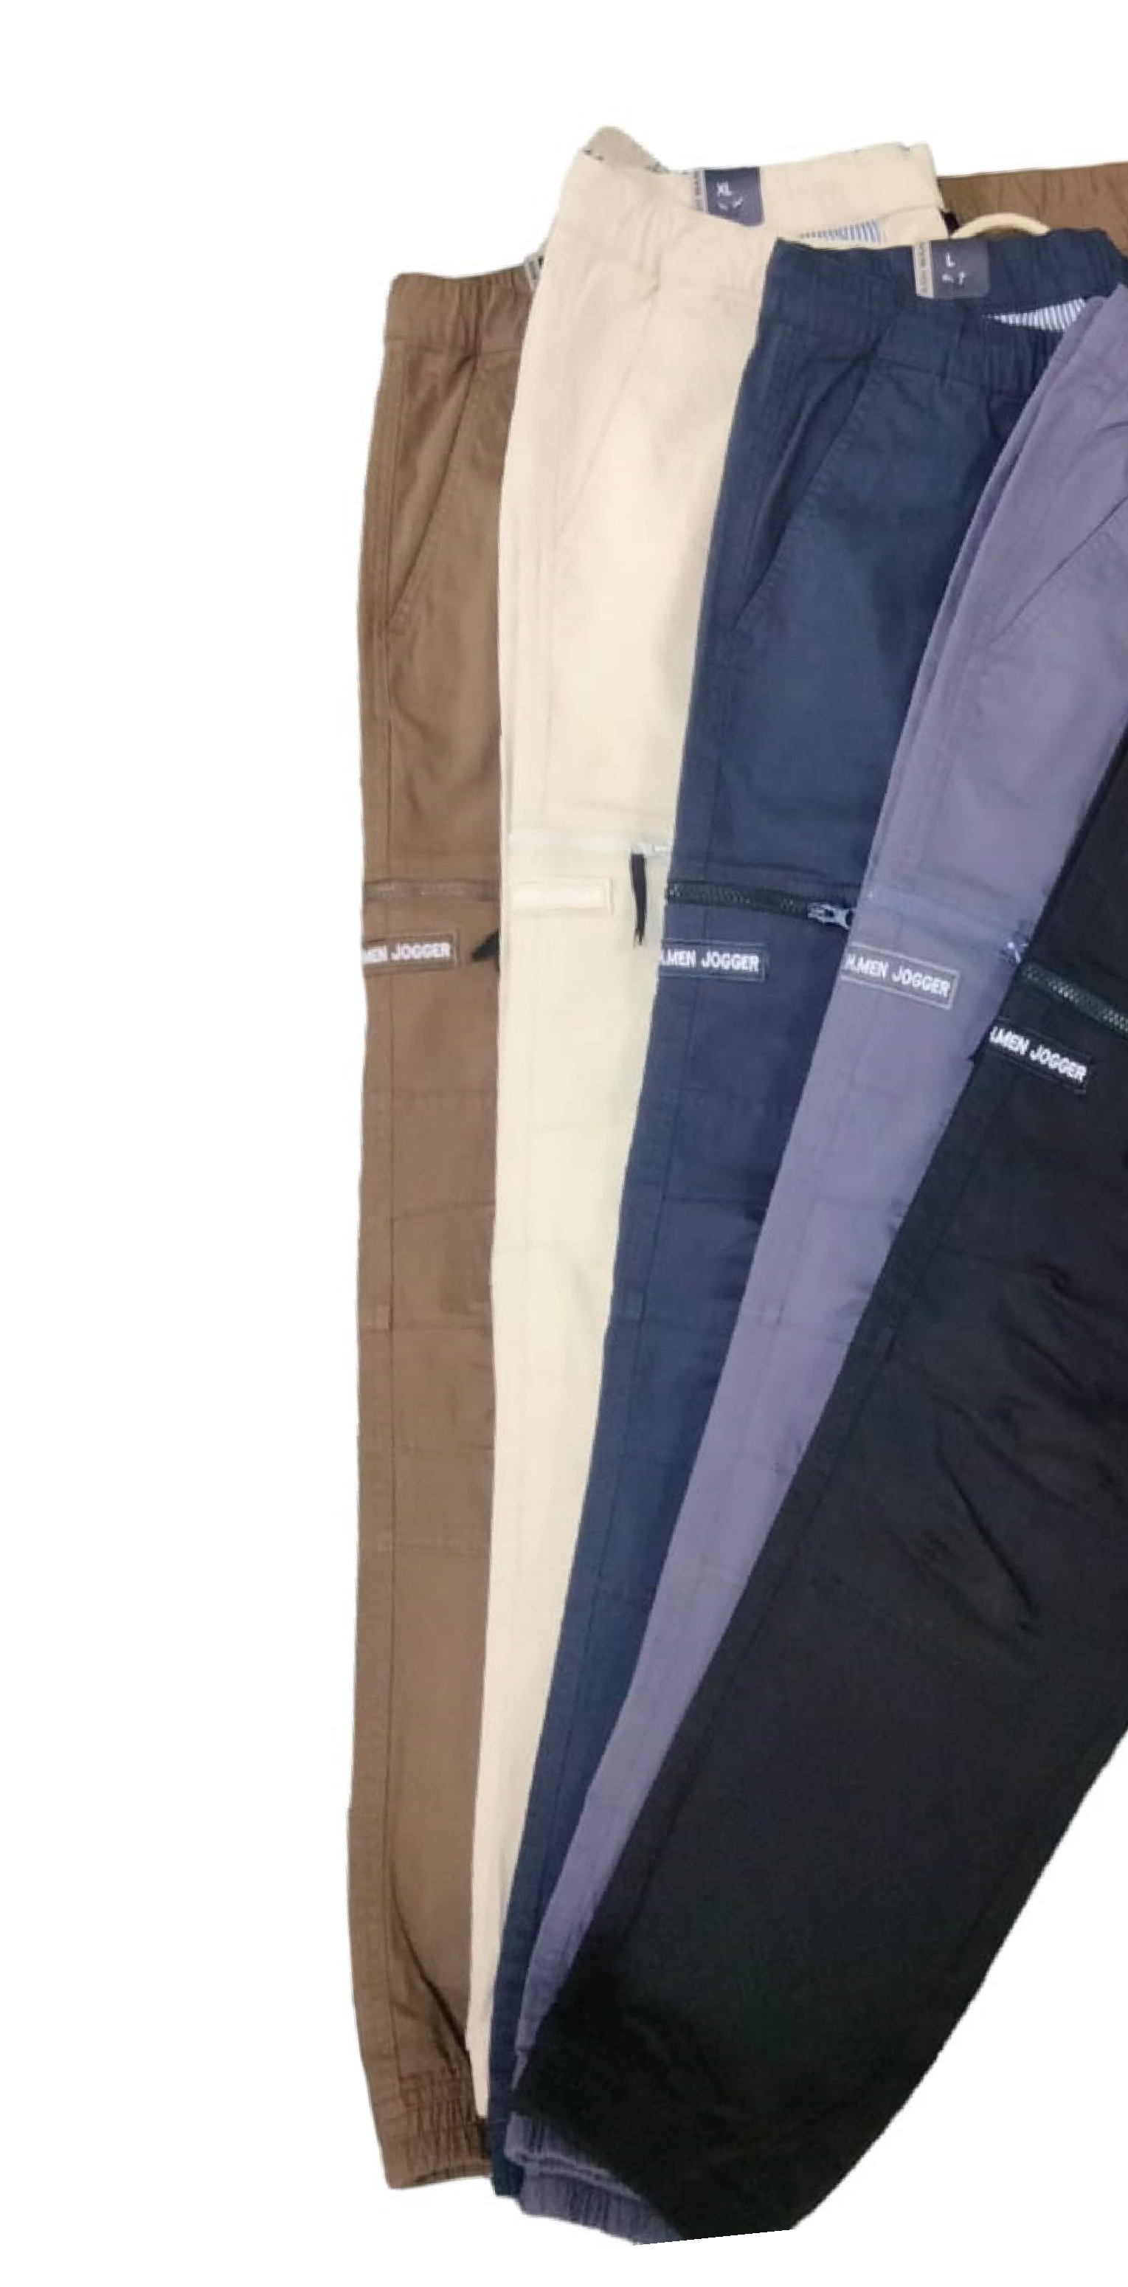

**MEN’S JOGGER**

Men's joggers have evolved into a popu

lar

choice

for

modern,

casual

wear,

blending

style

and

comfort

effortlessly.

Crafted typically from soft, stretchy fab

rics like cotton blends or fleece, joggers

are designed with an elasticated waist

band and cuffs, offering a relaxed fit with

a

tapered

leg.

Joggers

have

become

a

go-to option for those seeking versatile

attire

suitable

for

a

range

of

activities,

from leisurely strolls to light workouts.

The material used in joggers varies, but

commonly

includes

blends

that

offer

breathability

and

durability,

ensuring

comfort

for

wearers

throughout

lasting

their daily activities. This comfort factor

market

segments

often

appeals

to

inclined towards athleisure or individuals

seeking

a

balance

between

relaxation

and

style,

making

joggers

a

preferred

less

flexible

choice

over

more

rigid

or

trousers.

For

brands

targeting

a

demographic

leaning

towards

relaxed,

athletically-in

spired fashion, partnering with us in the

guarantees

manufacturing

process

exceptional

quality.

We

pride

ourselves

on utilizing premium materials and em

construction

ploying

cutting-edge

methods to produce joggers that strike

the perfect balance between style, com

fort, and durability.

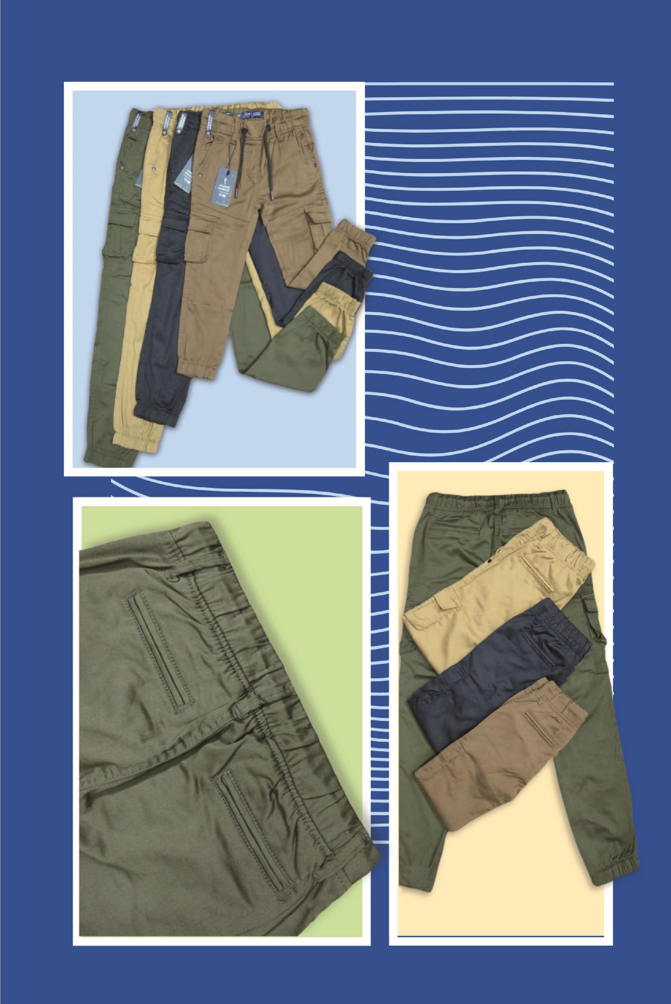

**JEWEL**

**DESIGN**

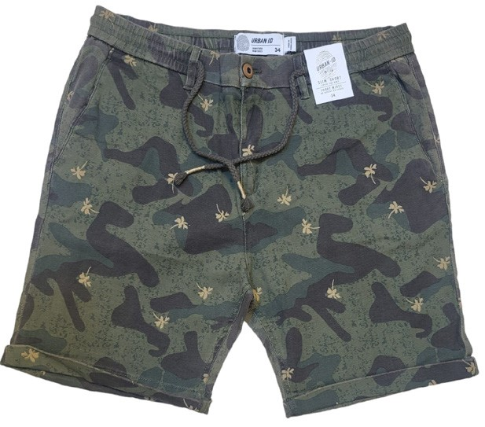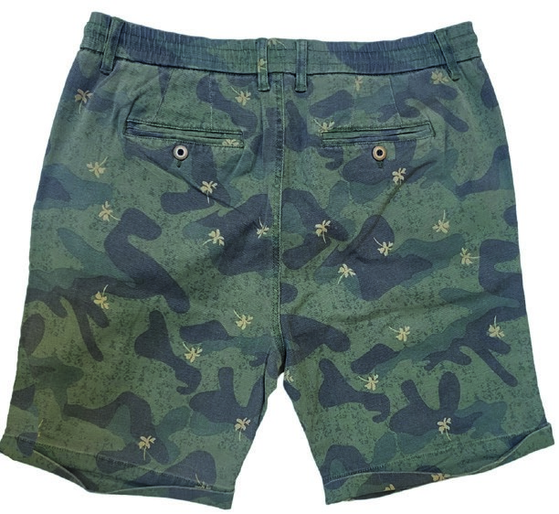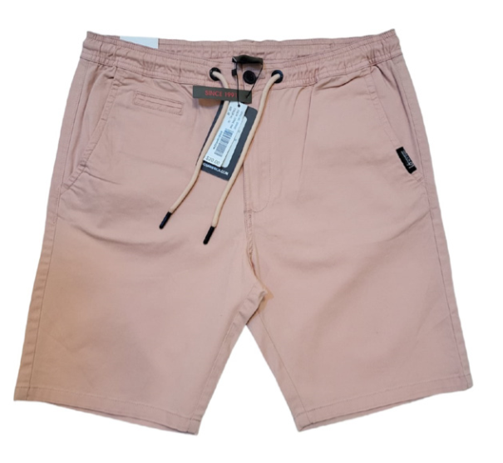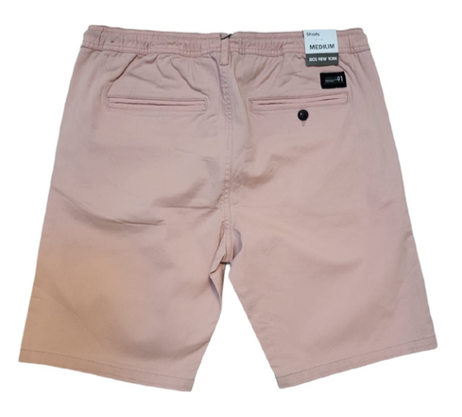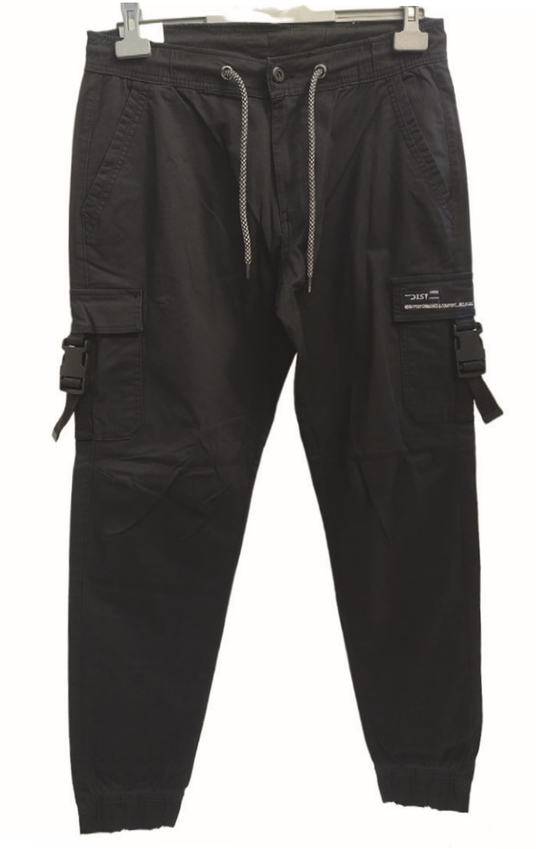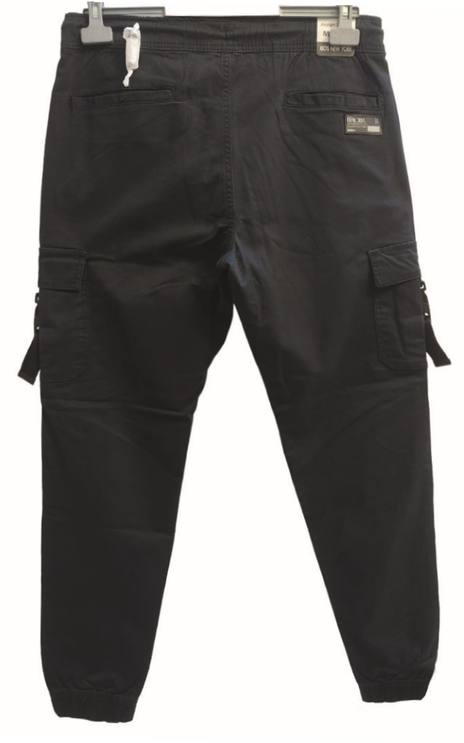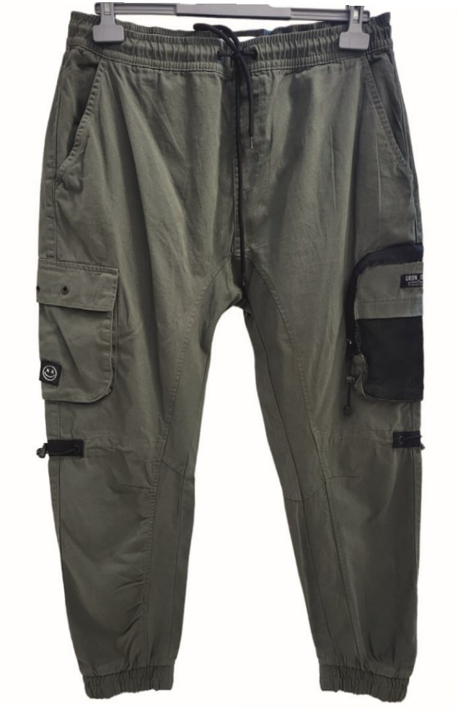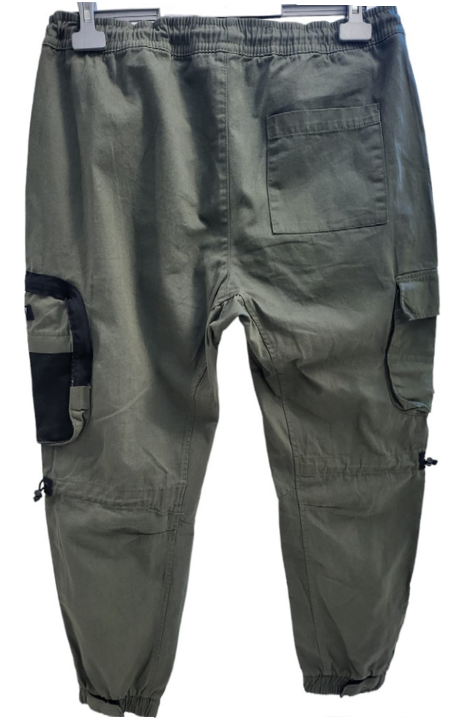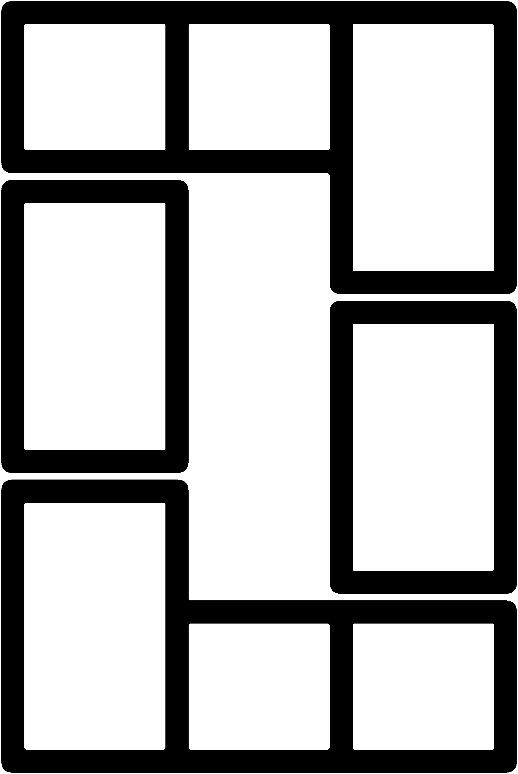

|  |
| --- |
| **PRODUCTION CAPACITY**  **Jewel Design Limited is a leading manufacturer of woven bottoms, with a monthly production capacity of 120,000 pieces and a daily capacity of 6,500 pieces. The company's greatest strength is its focus on bottoms, which makes it a specialist factory in this category. Jewel Design Limited has a state-of-the-art production facility with the latest equipment and machinery, and it is also committed to sustainable manufacturing practices.** |

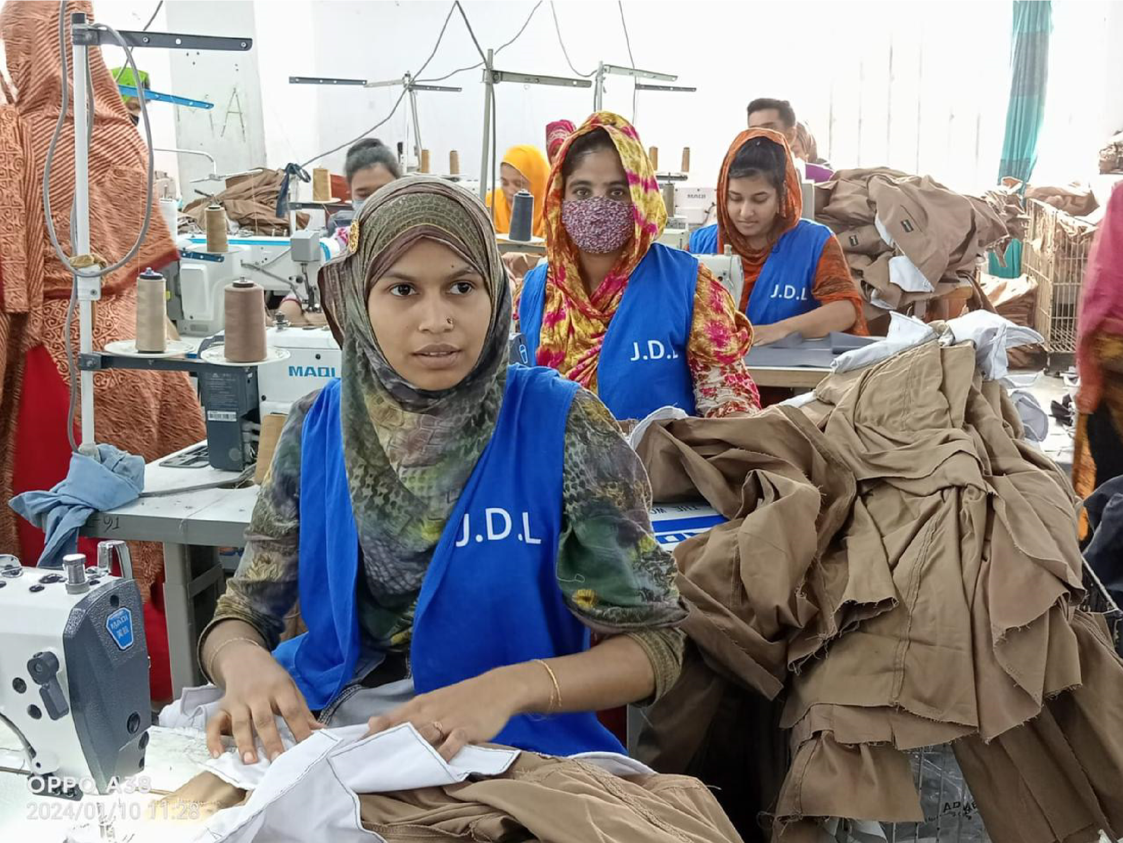

Jewel Design Limited's focus on bottoms allows it to specialize in the production of this type of garment. This specialization gives the company a number of advantages, including:

**Deeper expertise:** We have a deep understanding of the specific needs of bottom garment production. This expertise allows the company to produce high-quality bottoms that meet the needs of its customers.

|  |
| --- |
| raw materials are manufactured in-house” |

**Efficiency:** Our specialization allows it to streamline its production process and achieve greater efficiency. This efficiency translates into lower costs for the company and its customers.

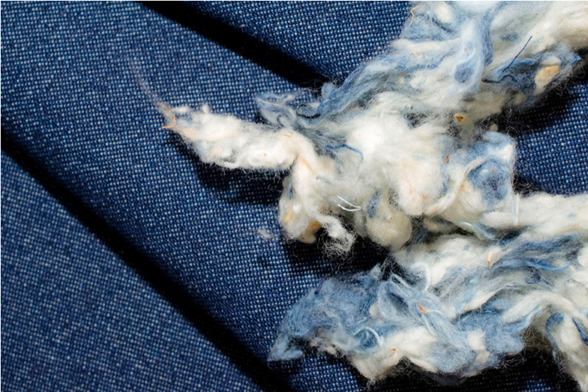

**70**

**%**

**Design Iteration:** We are able to iterate through various designs more quickly than a company that produces a wider range of garments. This is because the company has a dedicated team of experts focused on bottom garment production.

The Company’s state-of-the-art production facility gives the company a number of advantages, including:

bottoms quickly and cost-effectively.

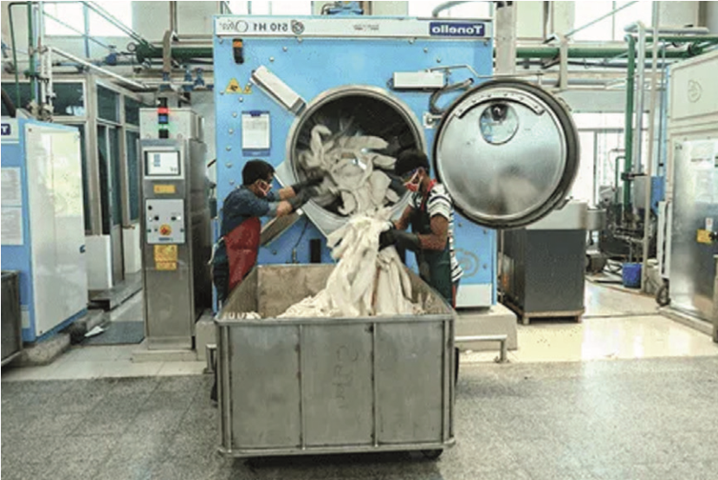

done in-house

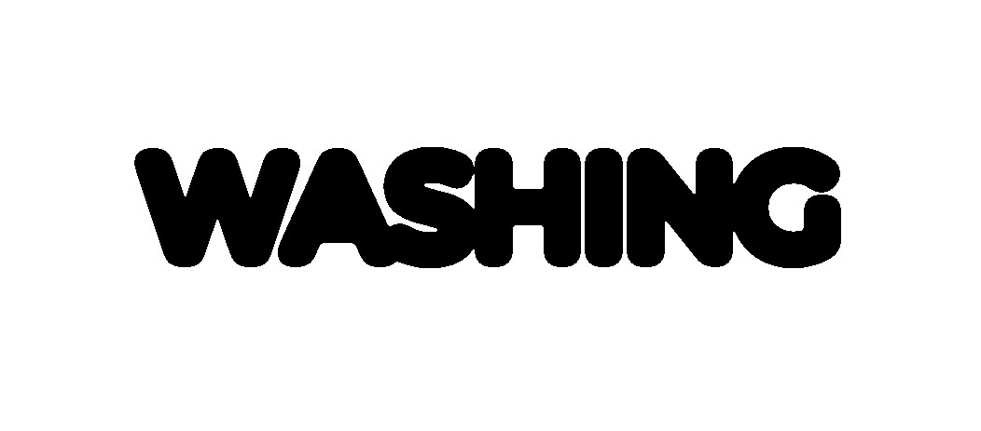

**WASHING**

**Accuracy:** The company's equipment is highly accurate, which allows it to produce bottoms with consistent quality.

**Speed:** The company's equipment is also highly efficient, which allows it to produce

**Flexibility:** The company's facility is flexible enough to accommodate changes in demand and production requirements.

Our

focus

on

bottoms,

state-of-the-art

production

fa

cility, and commitment to sus

tainable

manufacturing

prac

the

in

a

leader

tices

make

it

bottoms

woven

industry.

The

company

is

well-positioned

to

meet the needs of its custom

and

ers

for

high-quality

af

fordable bottoms.

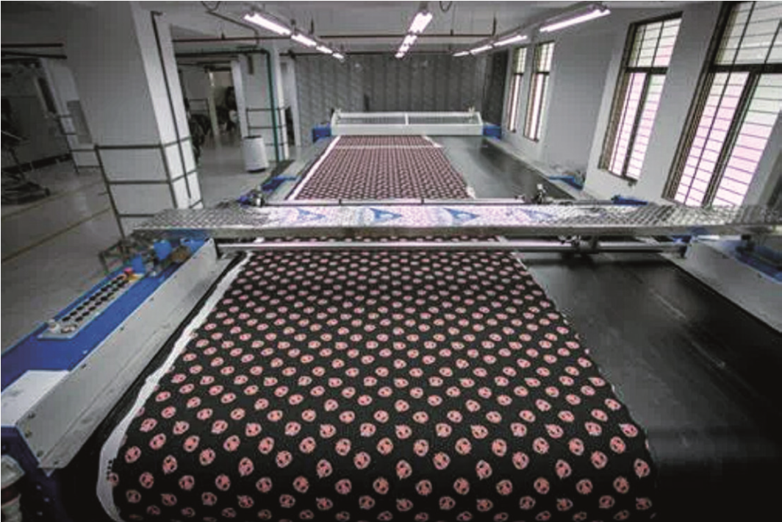

**PRINTING**

done in-house

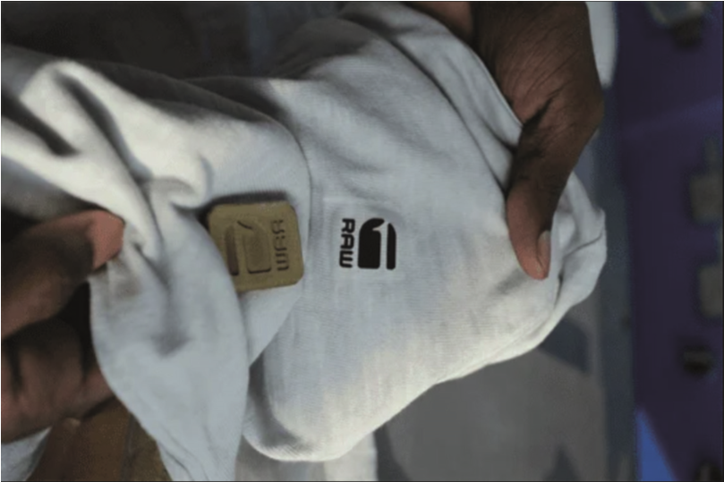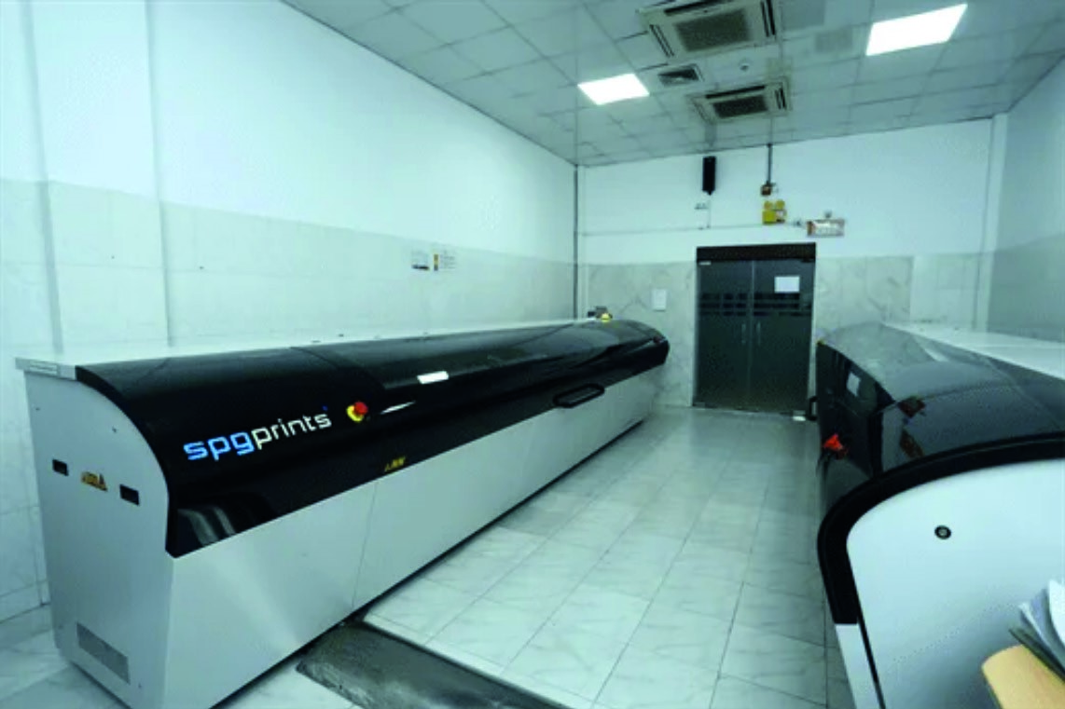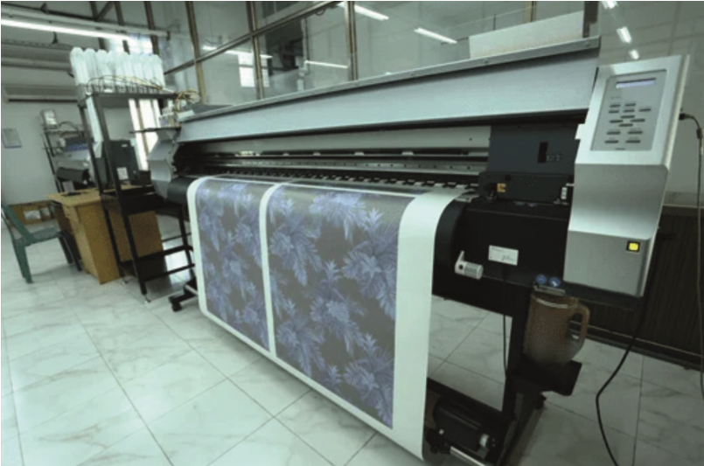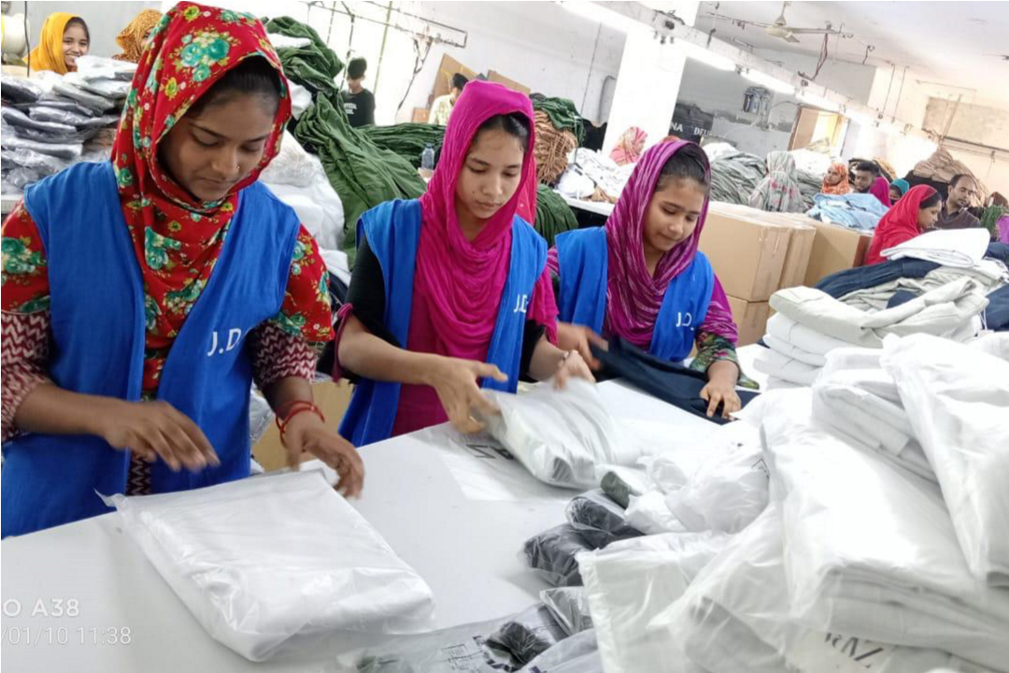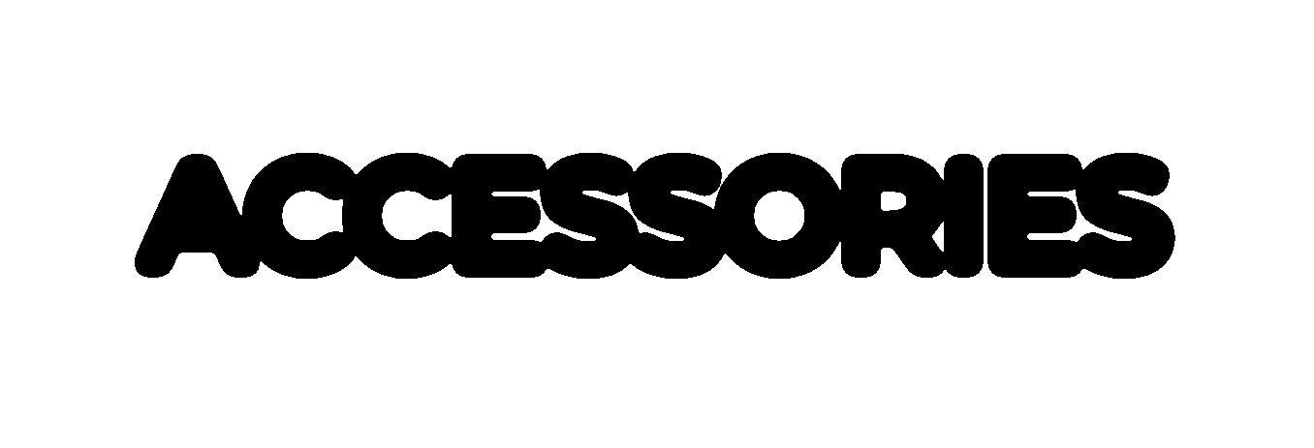

manufactured in-house

**ACCESSORIES**

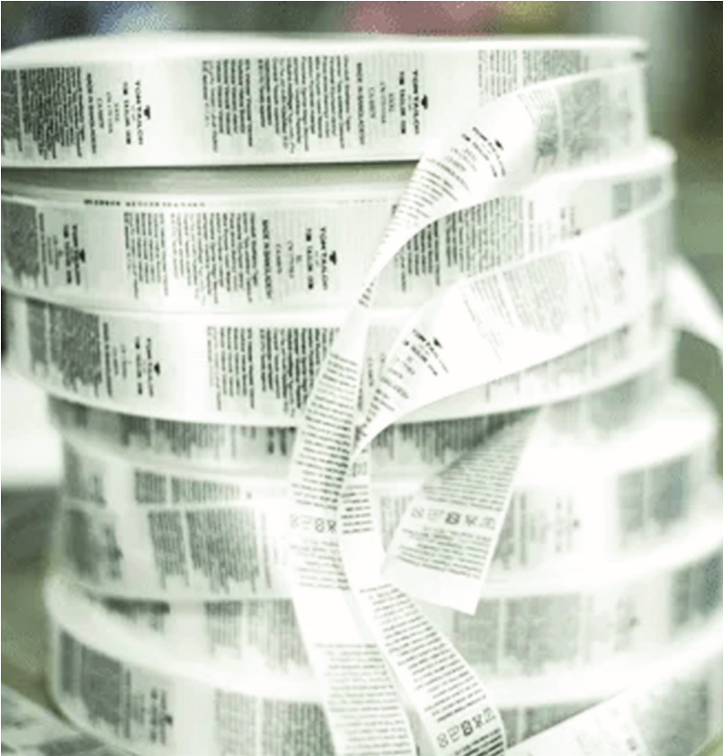

# LIST OF MACHINES

|  |  |  |  |  |
| --- | --- | --- | --- | --- |
| **SL NO** |  |  | | **TOTAL QTY (PCS)** |
| 01 |  | Eye Let Hole | | 03 |
| 02 |  | Over Lock (4-thread) | | 80 |
| 03 |  | Over Lock (5-thread) | | 30 |
| 04 |  | Flat Over Lock ( 5-thread) | | 27 |
| 05 |  | Lock (Sylender Bed) | | 56 |
| 06 |  | Lock (Flat Bed) | | 20 |
| 07 |  | Plain Machine Auto | | 110 |
| 08 |  | Two Niddle Chain Stitch | | 12 |
| 09 |  | Piping Machine | | 06 |
| 10 |  | Kansai Special | | 03 |
| 11 |  | FAB Cutting Machine | | 06 |
| 12 |  | Heavy Duty Feed Of The Arm | | 05 |
| 13 |  | Light Feed Of The Arm | | 05 |
| 14 | **,** | Bar Tack Machine | | 06 |
| 15 |  | Rib Cutting Machine | | 04 |
| 16 |  | Button Hole **,, ,** | | 04 |
| 17 |  | Button Stitch | | 06 |
| 18 |  | Snap Button | | 10 |
| 19 |  | Iron | | 13 |
|  | | **TOTAL** | | **406** |
| **Production Capacity per Day (8:00 AM to 5:00 PM)** | | | | **Average Monthly**  **Production Capacity**  **for Woven Bottoms** |
| **Item** | | | **Quantity (Pcs)** |
| Men’s Chino | | | 4000 |
| Cargo Pant | | | 3000 | **2 ,40,000 Pcs** |
| Men’s Jogger | | | 6000 |

# CLIENTS

**CANADA**



**AMERICA**



**UNITED KINGDOM**



**NORWAY**



**UAE**



**PHILIPPINES**

**LITHUNIA**



Jewel Design Limited has a strong customer base of satisfied **customers in Europe, the USA, Canada, and Australia**

**MEMBER OF**

  

Bangladesh Garments Bangladesh Export Bangladesh Chamber Manufacturers & Promotion Bureau of Commerce

Exporters Association ( BGMEA )

**CERTIFIED BY**

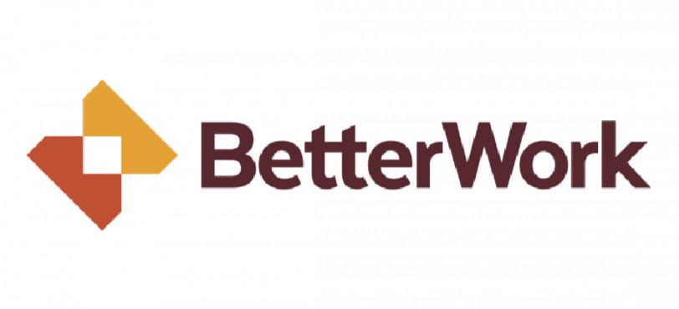

**INTO THE FUTURE**

We are looking to increase floor space and production capacity by new infrastructure which will be constructed on the Dhaka-Mawa Highway. With a total area of 2,00,000 sq.ft this will be part of the Jewel Design group of industries related to garments manufacturing. This will significantly increase production of a Company who are already experts in bottoms manufacturing.

|  |
| --- |
| **“On average all our employees have been**  **working with us for 10 years”** |

For the current set-up there is enough machinery and the company is looking to increase machinery with fresh investment for the new facility

which will be imported from China. The required transition will be carried out by the Management team with the help of its experienced team of Managers and line managers..With 315 employees Jewel design boasts a team of line managers and workers with an average career span of 10 years. This competent team will also take part in the hiring process further strengthening the Company to its core.

**GET IN**

**TOUCH**

**JEWEL DESIGN LTD**

**100**

**% Export Oriented Knit and woven units.**

**Phone: - 880-1972446300. 880-1915446300.**

**E-mail : info@jeweldesignltd.com , jewel101112@yahoo.com**

**Contact Person : Md Jewel Hossain**

**Factory Address**

**Dsection # 7, Avenue # 1, Plot # 4 & 5, Mirpur Dhaka 1216.**

**Bank**

**T/T Advising Bank :**

**COMPANY NAME: JEWEL DESIGN LTD**

**BANK NAME: JAMUNA BANK LTD**

**ACCOUNT NO: 00420210011226**

**S.W.I.F.T CODE: JAMUBDDH056**

**ADDRESS: Mirpur-10 Shenpara parbata, MIRPUR**

**DHAKA - 1216 BANGLADESH**

